TASK 1 — Linux IP Investigation
Identify the Linux IPv4 address, interface, route, and DNS configuration.
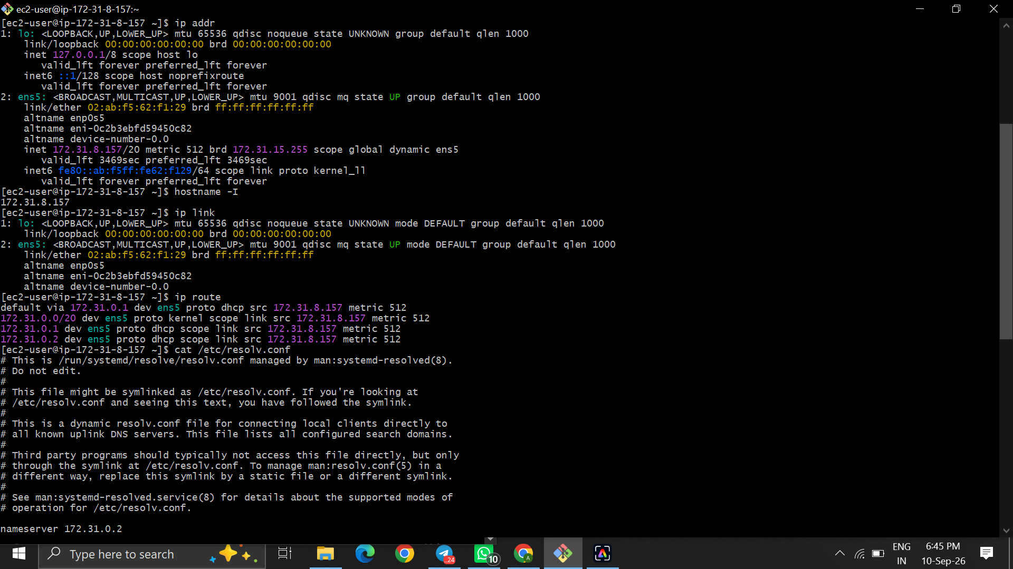  Figure 1 — Linux network configuration and DNS evidence. | 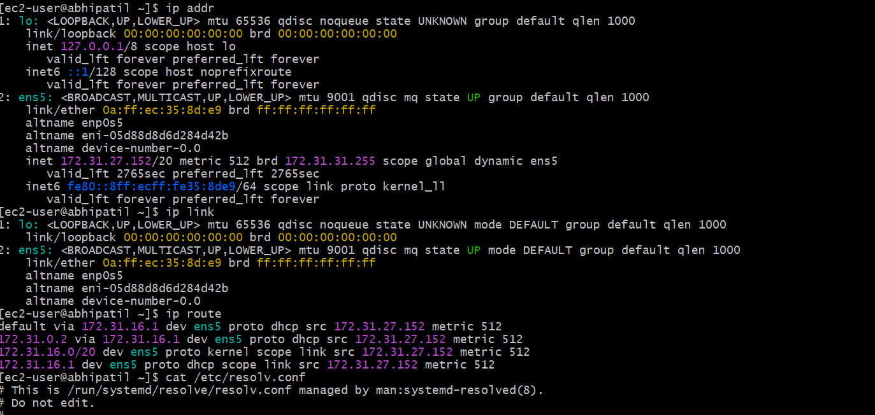  Figure 2 — Second Linux network configuration evidence.
  Command: ip addr; ip link; ip route; cat /etc/resolv.conf
  Observation: Interface ens5 and a private IPv4 address are visible, along with route and DNS configuration.
  Command: ip addr; ip link; ip route; cat /etc/resolv.conf
  Observation: A second Linux instance shows interface ens5 with private IPv4 172.31.27.152 and its route/DNS settings.
Documentation format: Command Used → Output/Observation → Result. Screenshots were selected from the supplied evidence; repeated captures were omitted.

TASK 2 — IPv4 Address Analysis + TASK 4 Evidence
Compare cloud-console IPv4 values with the values obtained from inside Linux.
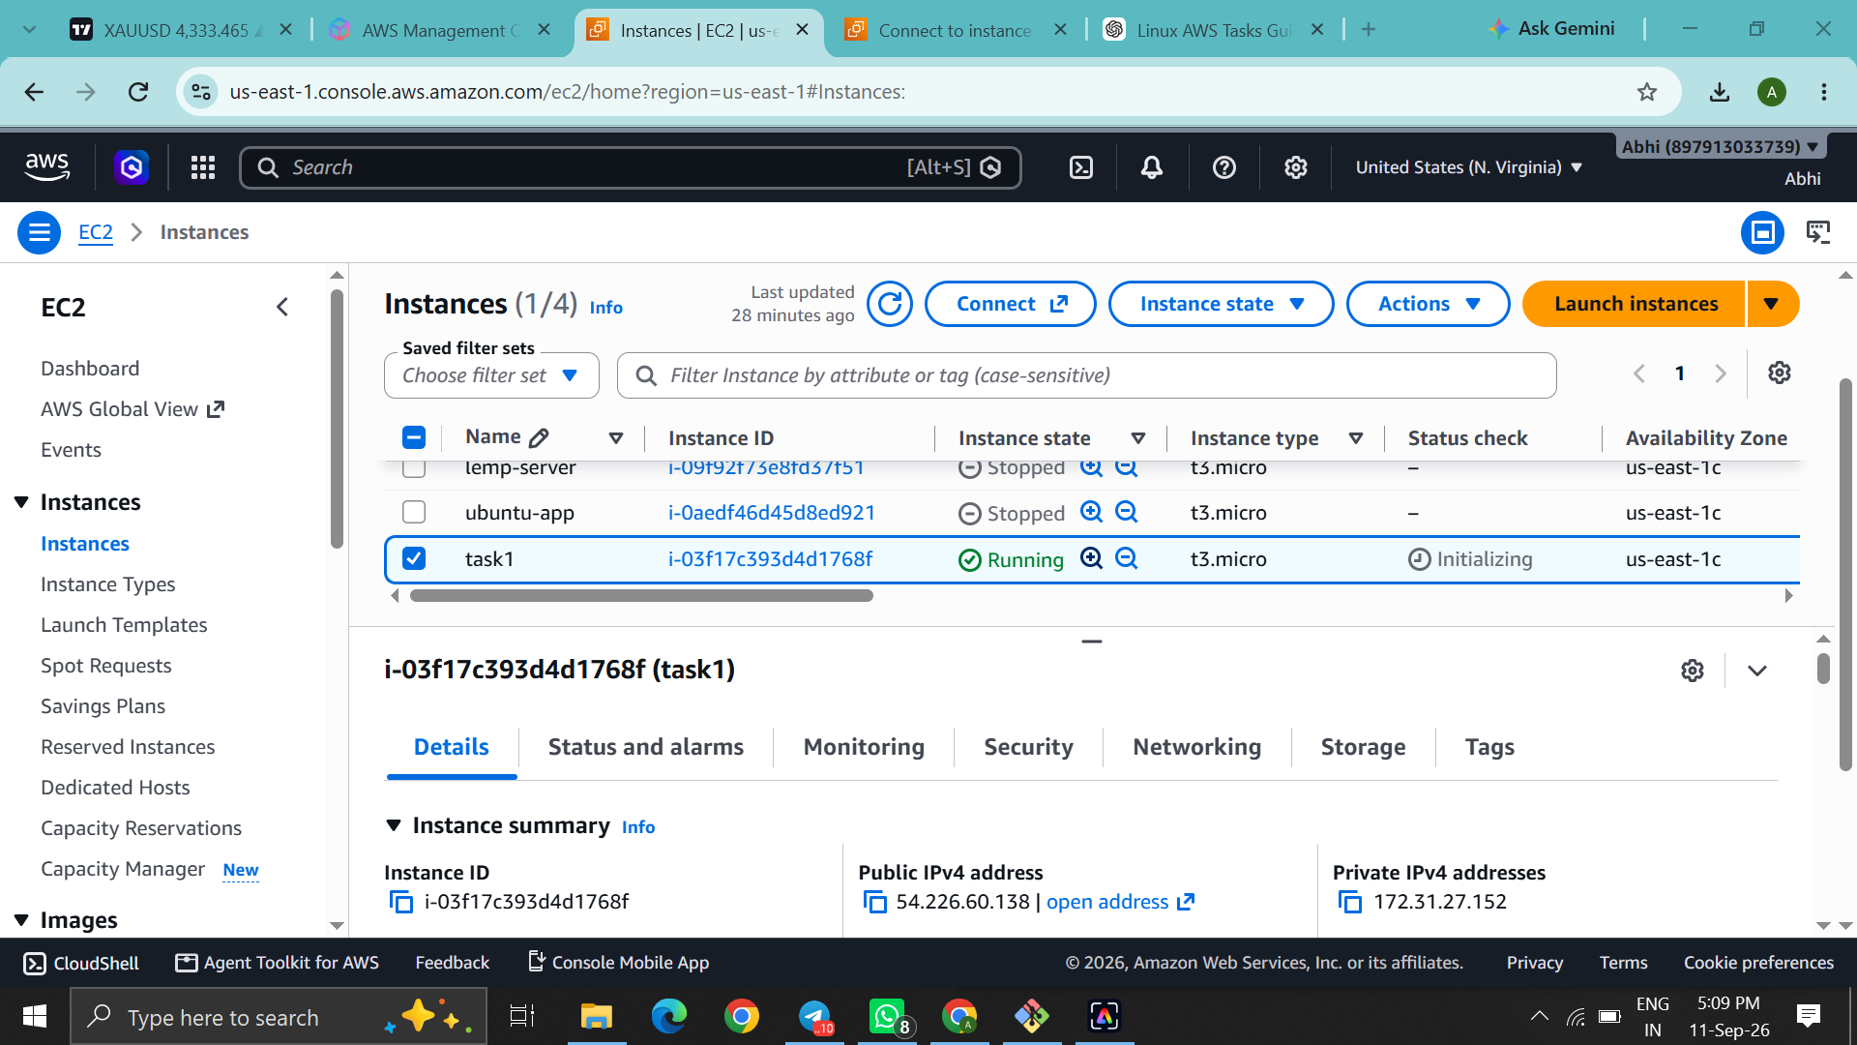  Figure 3 — AWS EC2 console address information. | 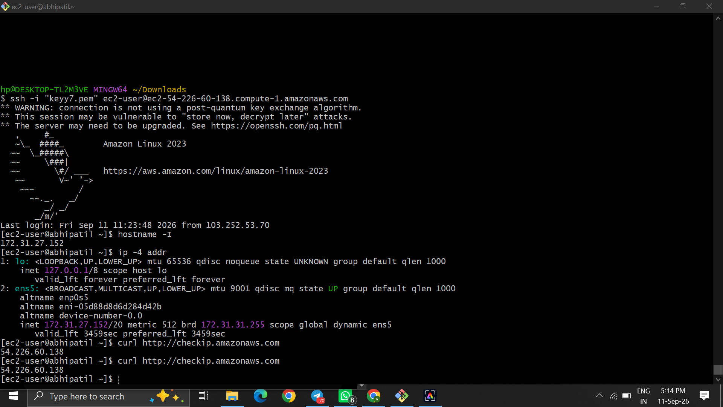  Figure 4 — SSH session with IPv4 and public-IP checks.
  Command: AWS EC2 → Instances → task1
  Observation: The console shows Public IPv4 54.226.60.138 and Private IPv4 172.31.27.152.
  Command: hostname -I; ip -4 addr; curl http://checkip.amazonaws.com
  Observation: Inside Linux, private IP 172.31.27.152 and public IP 54.226.60.138 are shown.
Documentation format: Command Used → Output/Observation → Result. Screenshots were selected from the supplied evidence; repeated captures were omitted.

TASK 3 — Dynamic IP Investigation
Record the address before/after reconnect testing and retain supporting network evidence.
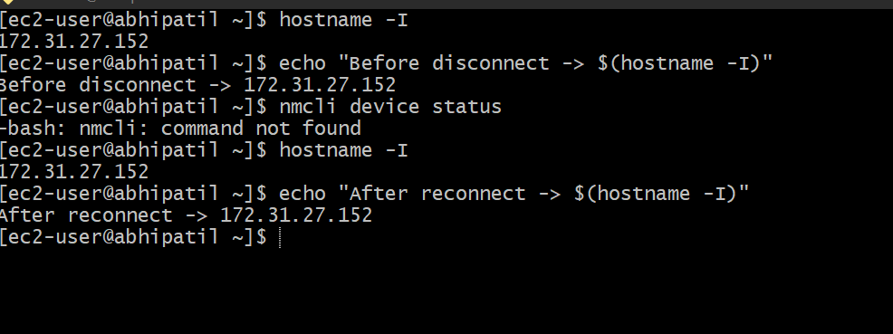  Figure 5 — Before/after dynamic IP record. | 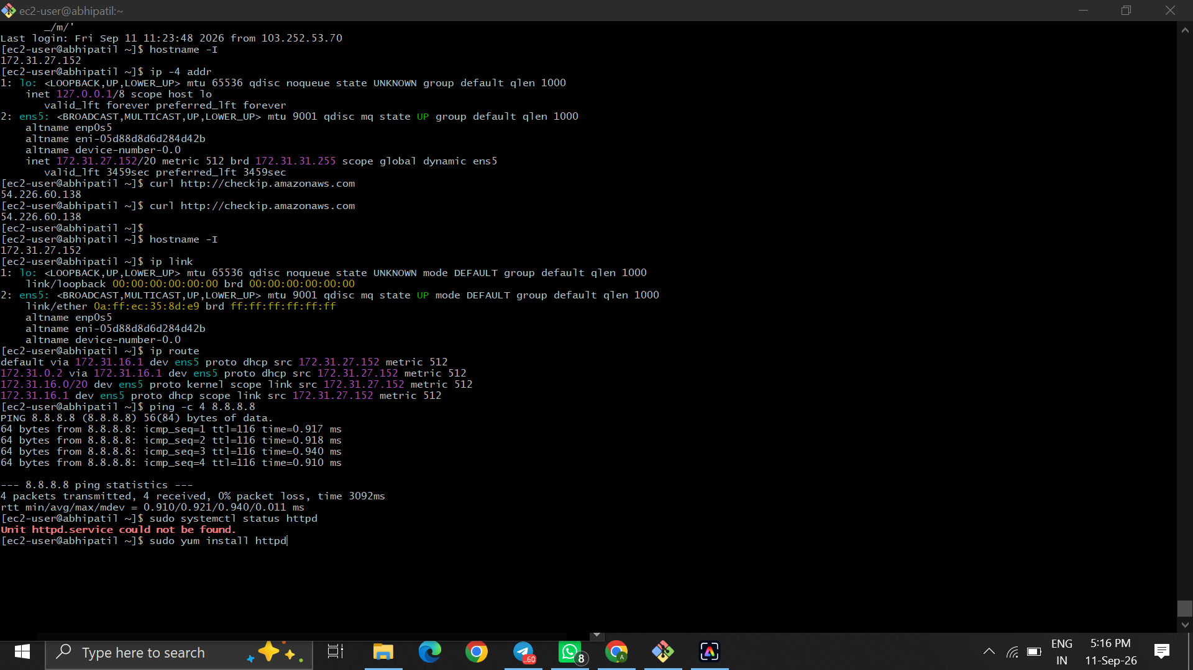  Figure 6 — Supporting network reachability and service-check evidence.
  Command: hostname -I; echo "Before disconnect -> $(hostname -I)"; echo "After reconnect -> $(hostname -I)"
  Observation: The recorded address remained 172.31.27.152. The screenshot also shows that nmcli was unavailable.
  Command: ip route; ping -c 4 8.8.8.8; sudo systemctl status httpd
  Observation: The default route and Internet connectivity test succeeded; the initial httpd service check reported the unit was not found.
Documentation format: Command Used → Output/Observation → Result. Screenshots were selected from the supplied evidence; repeated captures were omitted.

TASK 5 — Cloud Network Troubleshooting
Verify the service, its listening port, and the final working state.
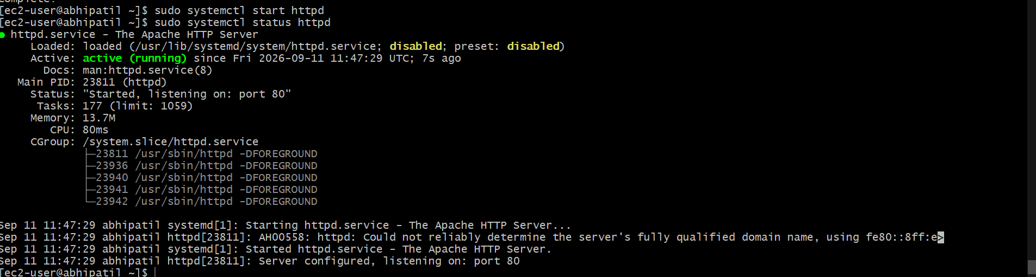  Figure 7 — Apache service successfully started. | 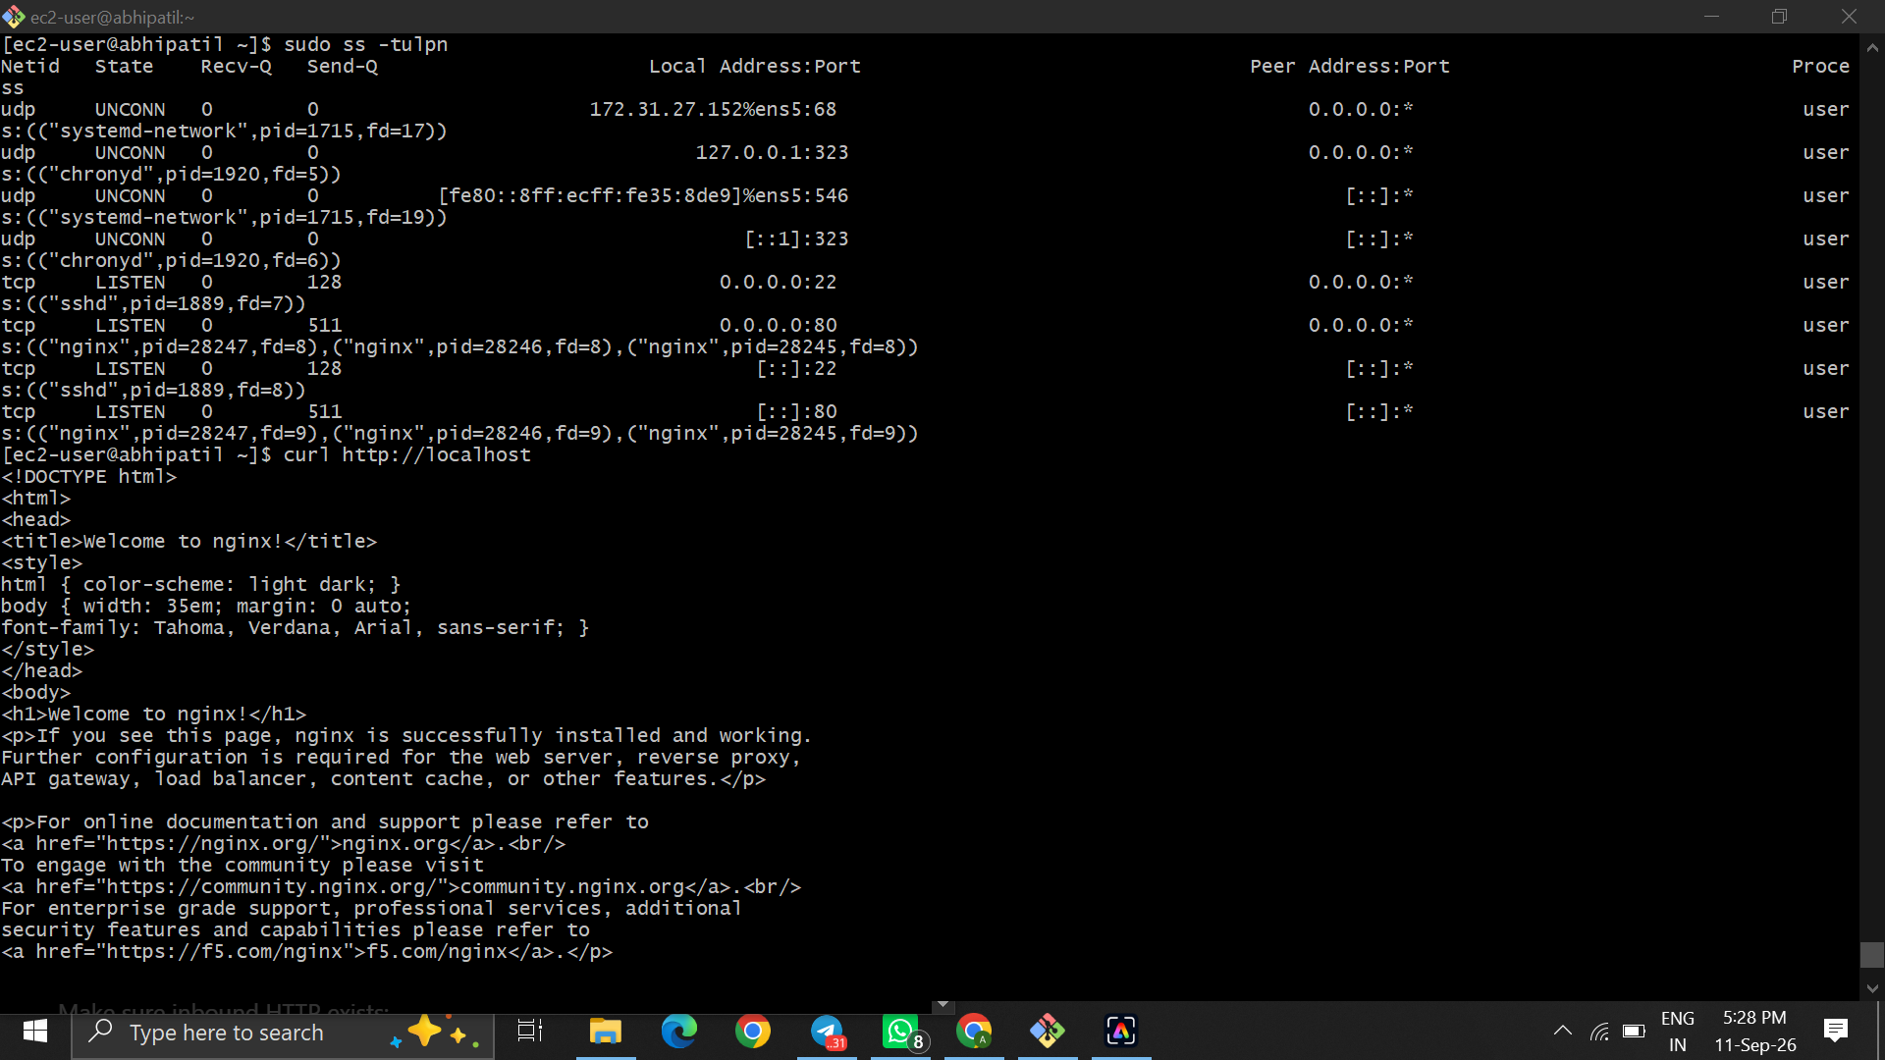  Figure 8 — Listening ports and local HTTP verification.
  Command: sudo systemctl start httpd; sudo systemctl status httpd
  Observation: Apache httpd is active (running) and reports that it is listening on port 80.
  Command: sudo ss -tulnp; curl http://localhost
  Observation: Port 80 is listening and the local HTTP request returns the nginx welcome page.
Documentation format: Command Used → Output/Observation → Result. Screenshots were selected from the supplied evidence; repeated captures were omitted.

TASK 5 — Cloud Network Troubleshooting (continued)
AWS security rules and web-service configuration evidence.
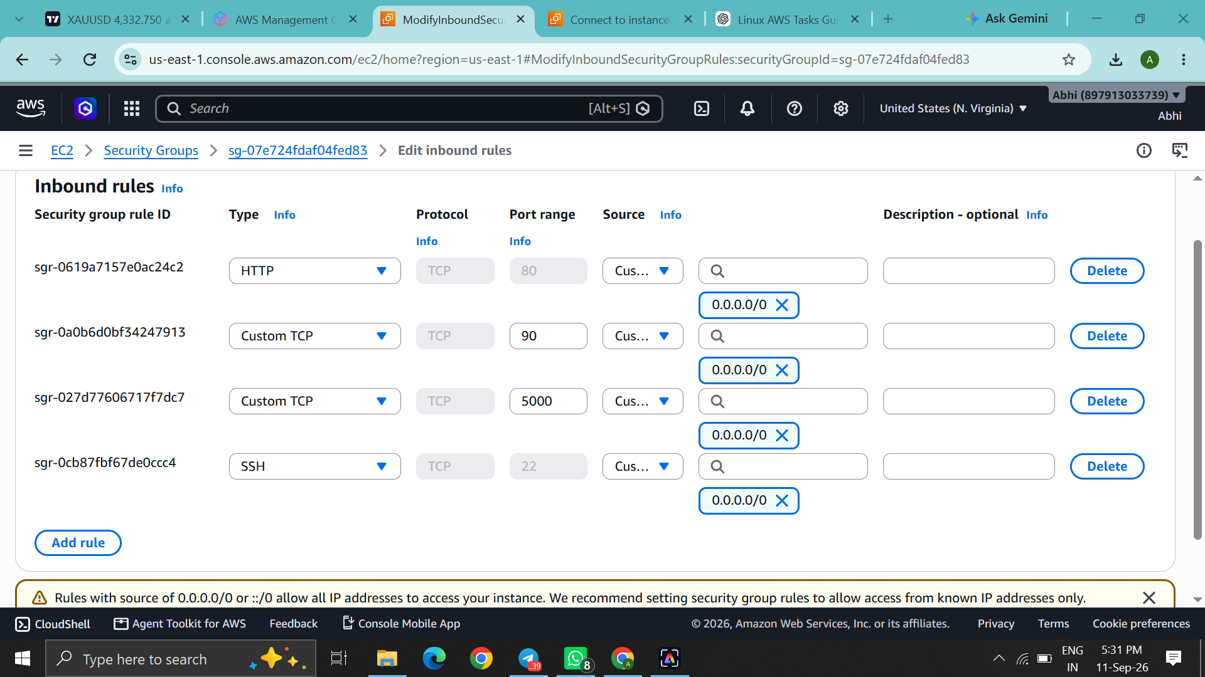  Figure 9 — AWS Security Group inbound rules. | 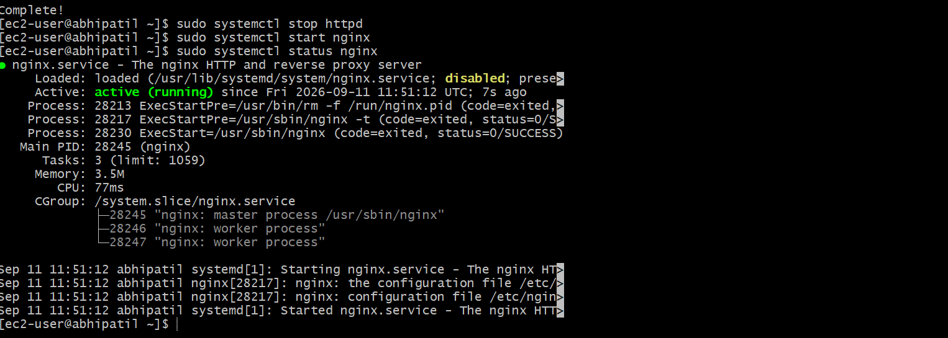  Figure 10 — Nginx service status after configuration.
  Command: EC2 → Security Groups → Inbound rules
  Observation: HTTP/TCP 80 is allowed from 0.0.0.0/0; SSH 22 and other lab ports are also shown.
  Command: sudo systemctl stop httpd; sudo systemctl start nginx; sudo systemctl status nginx
  Observation: Nginx is active (running), providing the web service after Apache was stopped.
Documentation format: Command Used → Output/Observation → Result. Screenshots were selected from the supplied evidence; repeated captures were omitted.

